
Welcome to Eclipse Recruitment

Thank you for registering with Eclipse Recruitment.
Below is some information you must be aware of whilst working for us.

Contact Details (24 hours per day, 365 days per year)

Bookings – Nadine, Simran, Kelly & Ben 0115 7044777 (24/7)
Accounts/Payroll – Nicole 0115 855 0530 (Monday to Friday 9-5)

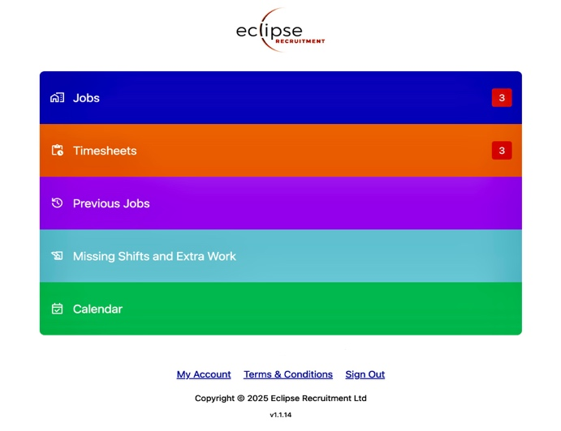
Eclipse Recruitment Driver Portal

The portal is your central hub for managing bookings. You can:
✔ Receive, accept, or decline jobs
✔ Complete timesheets
✔ See previous shifts completed
✔ Add Any Missing Shifts
✔ Update your availability

Access the portal here or log onto the Eclipse Website at www.eclipse-recruitment.com and click the Driver Portal button in the header.
Refer to the user guide below for more details.

Reporting for Work

Once you accept a job, you must arrive at the agreed time and location. If you are delayed or unable to attend, call Eclipse immediately at 0115 704 4777—we are available 24/7, 365 days a year.

On-Site Conduct

While on our customer’s premises, you are under their instruction for the duration of your booking. Always treat them and their customers with professionalism, respect, and courtesy. If you encounter any issues, call Eclipse first—we are here to support you.

Stay Updated

Follow us on Facebook for job updates and news: Eclipse Recruitment Facebook

Payment Information

As discussed during your interview, you will be paid via:
Standard PAYE or Umbrella PAYE, OR
Limited Company (Ltd) if you are eligible.

If you wish to invoice us as a Ltd company, you must provide:
Certificate of Incorporation
Proof of a business bank account

Until we receive these, your wages will be processed as PAYE. You can only invoice for shifts worked after submitting the required documents.

We look forward to working with you! If you have any questions, don’t hesitate to call.

Using the Eclipse Recruitment Drivers Portal on your devices
Once you have submitted your application form and successfully registered with Eclipse the Application Form will become your personal Eclipse Drivers Portal.
This Web Application is constantly developing, and reviews and modifications are made regularly. The Web address is https://www.eclipse-app.co.uk/. You can log in with the email address and password you used to register your application. The application currently has five sections. Below is a brief explanation of each section and how to use it.
Jobs
This is where you will see all current and upcoming jobs you have been booked into.
- You will receive a call from our Operations Staff informing you of the booking.
- Log onto the Portal, you will see a number in the job section. This indicates how many bookings have been allocated to you. Click on the “Jobs” section to open it.
- The left margin will show a red line for bookings that have not been responded to and a green line for bookings that have been responded to.
- Open each booking, and you will see the date and start time of the booking, the client, the class of vehicle, and the address to which to report. You’ll also have a direct link to Google Maps to see the client on a map. At the same time, you will receive an email with extended information about the job, such as special instructions, Health and safety and pay rates.
- Click on either “Accept” or “Reject” and then click “Respond”.
- If you click “Reject” the job will disappear from your portal.
- If you click “Accept,” the job will turn green, and the notification will disappear from the main Jobs Section.
- Once you have accepted this booking, you cannot change anything through the app. If you do need to change anything or something happens that means you are no longer available, then you must phone our 24- hour number and speak to a consultant. 0115 7044777
- The Accepted booking will remain visible until the day after it was booked.
In the future this will provide more information, including pay rates and any special instructions for booking.
Submit Timesheets
Once you have finished a booking, it will transfer to the timesheet section, and a notification will appear in the main Submit Timesheet Menu.
- Open the main Submit Timesheet section.
- You will see timesheets for all completed bookings that need hours submitted.
- Open the booking and complete all sections of the timesheet, or then click "Submit”.
- This will be checked against the client’s records, and if it all matches, you don’t have to do anything else. If it doesn’t match what the client enters, our payroll staff will contact you to rectify any errors.
- Once the timesheet has been submitted, it will disappear from the timesheet section.
- If you do not complete the timesheet, we will take the client’s timesheet and pay you based on that. The timesheet will then disappear from the Timesheet Section.
Completing the timesheet at the end of every shift rather than leaving it until the end of the week should become a good practice.

Previous Jobs
Here are all the bookings you have previously completed for Eclipse Recruitment. Click on each individual booking to view its details.
Missing Shifts and Extra Work
This is where you should record any missing shifts or additional work completed outside of Eclipse Recruitment.
Please follow the guidance below when entering your information:
Use the drop-down menu to select the appropriate category.
- Eclipse Missing Shifts: Shifts you were directly asked to complete by a client, but which are not yet recorded on our database.
- Non-Driving Work: Any other type of work you performed during the relevant period (not involving driving).
- Non-Eclipse Driving Work: Any driving work completed for other agencies or your own full time job.
Please ensure that all entries are as accurate and detailed as possible. This helps us maintain up-to-date records of your working and driving hours, supporting legal compliance and reducing the risk of driver infringements. You are ultimately responsible for keeping a weekly record of your activities.
Calendar
This is a calendar linked directly to our database. It allows you to give us your availability, book time off, or let us know if you’re doing other work.
By filling this in and keeping it updated, you will be added to the list of available drivers for any days that you are avail- able to work. It will also prevent us from bothering you if you’re unavailable for work.
- Click on a date and open the menu.
- Choose a status from the drop-down list.
- Choose a day or date range you want to inform us about.
- Insert a note if you need to.
- Click “Save”
- You can amend any of these entries at any time.
On larger-screen devices, a permanently displayed key shows the meaning of all the colours. The key can be accessed on smaller screens by clicking the small information (i) at the top of the screen.

If you have any suggestions for improvement or any problems using the Application, please email ops@eclipse-recruitment.com

